Titanic Survival Predictions

The article should contain the following sub-topics :
1.Problem Definition
2.Data Analysis
3.EDA Concluding Remarks
4.Pre-processing Pipeline
5.Building Machine Learning Models
6.Concluding Remarks

Introduction to data set-

The Titanic Problem is based on the sinking of the ‘Unsinkable’ ship Titanic in early 1912. It gives you information about multiple people like their ages, sexes, sibling counts, embarkment points, and whether or not they survived the disaster. Based on these features, you have to predict if an arbitrary passenger on Titanic would survive the sinking or not.

Problem Definition

The Titanic dataset provides observations for each passenger and the survival outcome. The problem statement entails predicting whether a passenger would survive or not survive given the features such as passenger class, sex, fair, age, number of siblings/spouse aboard, number of parents/children aboard, and others.

Data Analysis
There are data of 891 peoples who were on Titanic Ship.
1) In those 891 people 549 peoples didn’t survived and 342 are survived.

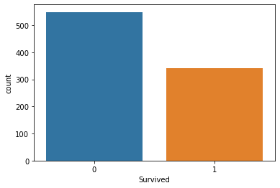
2) Number of females are more then male who survived.

3) survival rate of females in Pclass 1 is very high as compare to Pclass 2 and Pclass 3, where as survival rate of males in Pclass 3 is least .

4) according to data female survival rate is higher if age is between 18-80yrs old and from class 1. and survival rate of male in second class with age 18-80 yrs old is worst

5) according to this data Fare for class 1 is higher than other classes. and there are some people who doesn't pay anything in each class.

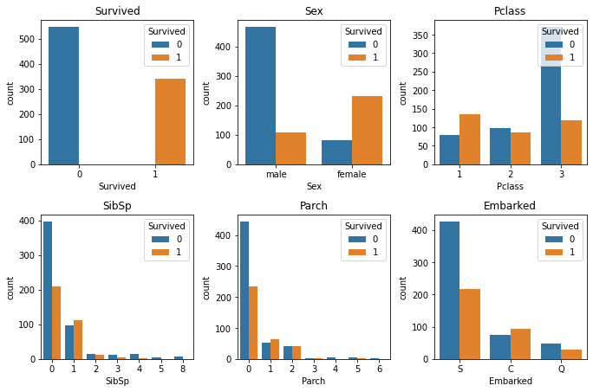

EDA Concluding Remarks

In the dataset there are some null values in Age and Cabin columns.
Code - data.isnull().sum()
output-
PassengerId 0
Survived 0
Pclass 0
Name 0
Sex 0
Age 177
SibSp 0
Parch 0
Ticket 0
Fare 0
Cabin 687
Embarked 2
dtype: int64

If we drop the null values we get almost 80% of data left with 712rows.
Code- data=data.dropna(subset=['Age','Embarked'])
code- data.shape
output-
(712, 12)

Pre-processing Pipeline
while checking the data types Sex and Embarked column have object values
and other all columns have integer and float values.
Code- data.dtypes
output- Survived int64
Pclass int64
Sex object
Age float64
SibSp int64
Parch int64
Fare float64
Embarked object
dtype: object

To convert the data into integers we have to encode the sex and embarked columns
by label encoder.
Code- from sklearn.preprocessing import LabelEncoder
labelencoder=LabelEncoder()
code- print(data['Sex'].unique())
print(data['Embarked'].unique())
output- ['male' 'female']
['S' 'C' 'Q']
code- data.iloc[:,2]=labelencoder.fit_transform(data.iloc[:,2].values)
data.iloc[:,7]=labelencoder.fit_transform(data.iloc[:,7].values)
code- print(data['Sex'].unique())
print(data['Embarked'].unique())
output- [1 0]
[2 0 1]

Building Machine Learning Models
As all of our columns are in integer and floats we can split the data for model building.
Code- data.dtypes
output-
Survived int64
Pclass int64
Sex int32
Age float64
SibSp int64
Parch int64
Fare float64
Embarked int32
dtype: object

code- x=data.iloc[:,1:8].values
y=data.iloc[:,0].values
We split our data as Survived column is the target column.
We import train_test_split from sklearn.
Code - from sklearn.model_selection import train_test_split
x_train,x_test,y_train,y_test=train_test_split(x,y,test_size=0.2,random_state=0)
We will test our data on different model simultaneously
1) logistic regression
code- def models(x_train,y_train):
code- from sklearn.linear_model import LogisticRegression
log=LogisticRegression(random_state=0)
log.fit(x_train,y_train)
code- print('[0]Logistic Regression training Accuracy: ' , log.score(x_train,y_train))
code- model=models(x_train,y_train)
output- [0]Logistic Regression training Accuracy: 0.7978910369068541
2) decision tree
code- def models(x_train,y_train):
from sklearn.tree import DecisionTreeClassifier
tree=DecisionTreeClassifier(criterion='entropy',random_state=0)
tree.fit(x_train,y_train)
print('[5]DecisionTreeClassifier training Accuracy:' , tree.score(x_train,y_train))
code- model=models(x_train,y_train)
output- [5]DecisionTreeClassifier training Accuracy: 0.9929701230228472

3) RandomForestClassifier
code- def models(x_train,y_train):
from sklearn.ensemble import RandomForestClassifier forest=RandomForestClassifier(n_estimators=10,criterion='entropy',random_state=0)
forest.fit(x_train,y_train)
print('[6]RandomForestClassifier training Accuracy:' , forest.score(x_train,y_train))
model=models(x_train,y_train)
output- [6]RandomForestClassifier training Accuracy: 0.9753954305799648

accuracy of Decision Tree Classifier is the highest

lets check the confusion matrix and accuracy for all the models on test data
Code- from sklearn.metrics import confusion_matrix
for i in range(len(model)):
cm=confusion_matrix(y_test,model[i].predict(x_test))
#extracting true negative,true positive,false negative and false positive
TN,FP,FN,TP=confusion_matrix(y_test,model[i].predict(x_test)).ravel()
test_score=(TP+TN)/(TP+TN+FP+FN)
print(cm)
print('Model[{}] Testing ="{}"'.format(i,test_score))
print()
output- [[75 7]
[19 42]]
Model[0] Testing ="0.8181818181818182"
[[54 28]
[12 49]]
Model[5] Testing ="0.7202797202797203"

[[73 9]
[14 47]]
Model[6] Testing ="0.8391608391608392"

according to the confusion matrix Random forest Classifier is the best in testing data and it is also second best in training data

let's make a prediction for someone that he /she can survive according to this model or not
#Pclass int64
#Sex int32
#Age float64
#SibSp int64
#Parch int64
#Fare float64
#Embarked int32
these are the important figures we have to include while predicting the survival or any person

code-
random_person=[[2,1,25,0,0,0,0]]

#scaling the survival
from sklearn.preprocessing import StandardScaler
sc=StandardScaler()
random_person_scaled=sc.fit_transform(random_person)

#prediction of survival using RandomForestClassifier
pred=model[6].predict(random_person_scaled)
print(pred)

if pred==0:
print('not survived:( ')
else:
print('you survived:) ')
output-
[0]
not survived:(

so our perdicted person not able to survived.

Concluding Remarks
This project aims to find factors that may affect survival probability of individual passengers and crew when disaster happens. I used 892 training data from Titanic case, while logistic regression, decision tree and Random Forest Classifier are implemented in this project.

Through this test, it is obvious to conclude that Random Forest Classifier can outperform among these three methods, according to the number of mislabeled test points. Also in terms of each factor, sex and passenger class are the two major factors that may determine survival of individual passenger, e.g. female and higher class passengers will be more likely to survive in this case.

